Health Care 360°
Real time vital human medical activities monitoring, activity status, prediction, anomaly detection, diagnose/decision support & value added features via wearable health devices using the techniques of artificial intelligence, cloud computing, IoT & aligned technologies.

Submitted By

Raja Ahmed Sajjad 18PWCSE1632
Syeda Fatima Ashoor 18PWCSE1640
Ashley Alex Jacob 18PWCSE1649

Supervised by
Engr. Naina Said


2021-22

Department of Computer Systems Engineering
University of Engineering & Technology, Peshawar

Certificate of Approval

We approve the project proposal of Raja Ahmed Sajjad, Syeda Fatima Ashoor and Ashley Alex Jacob titled “Health Care 360°” submitted to Department of Computer Systems Engineering, UET Peshawar in partial fulfillment of requirement for the degree of B.Sc. (CSE).

Engr. Naina Said ___ __________
Supervisor

Prof./Dr ___ __________
Evaluation Committee Head

Dr. Athar Javed Sethi ___ __________
FYP Coordinator, DCSE

Introduction
In our project, we are going to develop a minimal viable health care product, which can be used as per patient’s feasibility. We will be using wearable sensors to grab data of vital human organ activities more inclined towards real time vital human medical activities monitoring, activity status, prediction, anomaly detection, diagnose/decision support & value added features via wearable health devices using the techniques of artificial intelligence, cloud computing, IoT & aligned technologies.
The data from wearable sensors gets stored in real time on cloud, from where we will be implementing the techniques of artificial intelligence including machine learning, deep learning & computer vision to assess the biomarker values as per standards. Once we get the results, we are good to show them in our end-nodes a mobile application & a web app. We will be going to make this a completely reliable product by implementing other aligned features right into its core in-order to leverage its productivity.

Problem Statement:
We all know that medical and health services are at the pinnacle of success. But even though health is the foremost concern, having an enormous stream of funding resources, digitization and modernization in practice but still there’s a room for improvement in this regard because medical and health services are the basic needs as well as the medical sector includes a wide aspect of departments due to which it is not as easy to overcome the problems related to health care.
- Inclination towards less invasive techniques in health care
- Portability & feasibility in health care
- Economical solution targeting the under-previliged
- Distance between patient and medical expert/physician/Doctors
- Lack of proper digital apparatus and services
- Lack of Proper health care check-ups & monitoring of vital organ activities
Vital Signs—Most Important to be Monitored
- Body Temperature
- Blood Pressure
- Blood Glucose Levels
- Heart Rate
- Respiration Rate
- Oxygen saturation
- Electrocardiogram
- Skin Perspiration
Other Physiological Parameters
Motion Evaluation
Ambiance Parameters

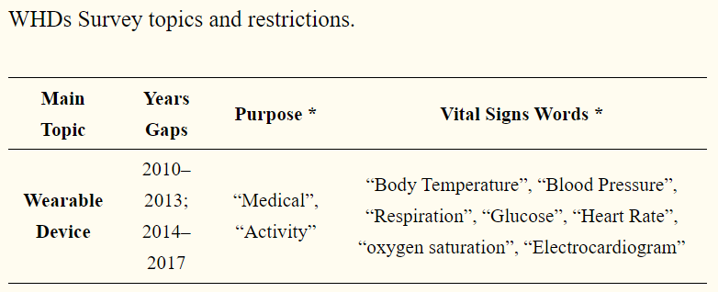
The human body has multiple different physiological signs that can be measured: from electrical signs to biochemical, human biosignals are possible to be extracted and be used to better understand the bodily health status and reaction to external factors. Before understanding how the signs are produced and how they can be acquired using wearable sensors and devices, it is of major importance to understand the main biosignals that contribute for a better human body health analysis. Nowadays technology and wearable scenarios let us classify WHDs according to three aspects: scenario of use (home/remote or clinical environment); the type of monitoring (offline or online); and the type of user (healthy or patient).
Regarding this classification, it is possible to divide WHDs in two main areas, activity monitoring area (1) and the medical area (2) that is divided in three main sub-categories.
(1) Activity area—where fitness/wellness and non-medical applications, self-monitoring and rehabilitation procedures are included.
(2) Prediction—consists in the identification of events that have not occurred yet, providing medical information to help in the prevention of further chronic problems, and sometimes, can support a diagnosis decision [11];
(3) Anomaly Detection—responsible for the identification of unusual patterns that are not conformed to the expected behaviour, based on classification methods to distinguish normal data from outlier data. Alarm is a subtask mainly used in anomalies detection, raising an alarm as soon as an anomaly is detected.
(4) Diagnosis Support—is one of the most important tasks of clinical monitoring, resulting in a clinical decision according to retrieved knowledge of vital signs, health records and anomaly detection data.

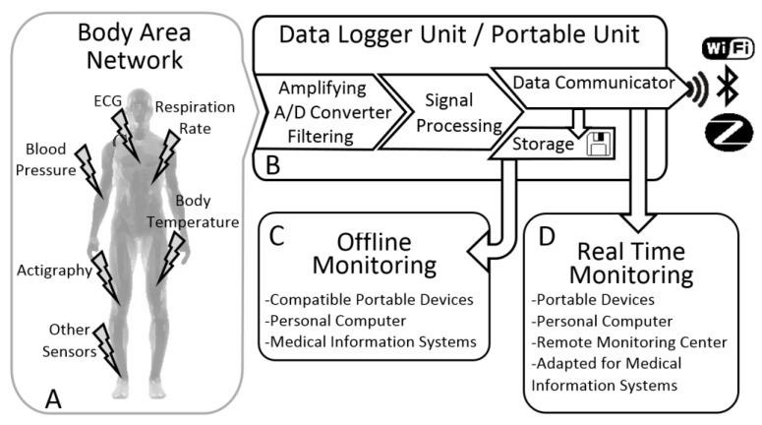

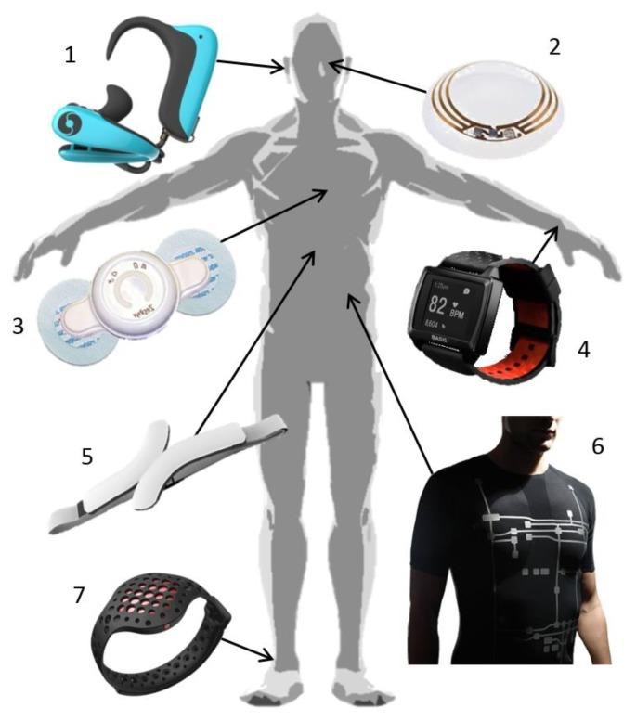

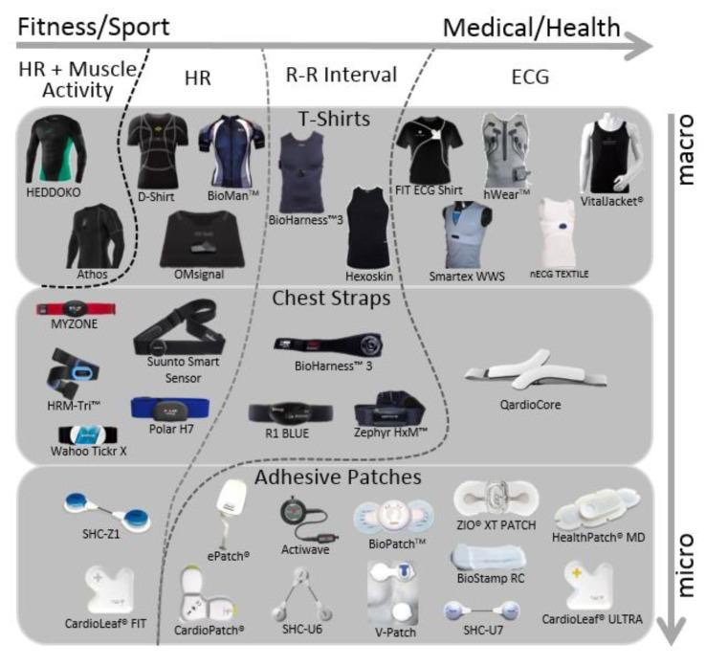
Source:
https://www.ncbi.nlm.nih.gov/pmc/articles/PMC6111409/

Industry Standardized measuring tools:
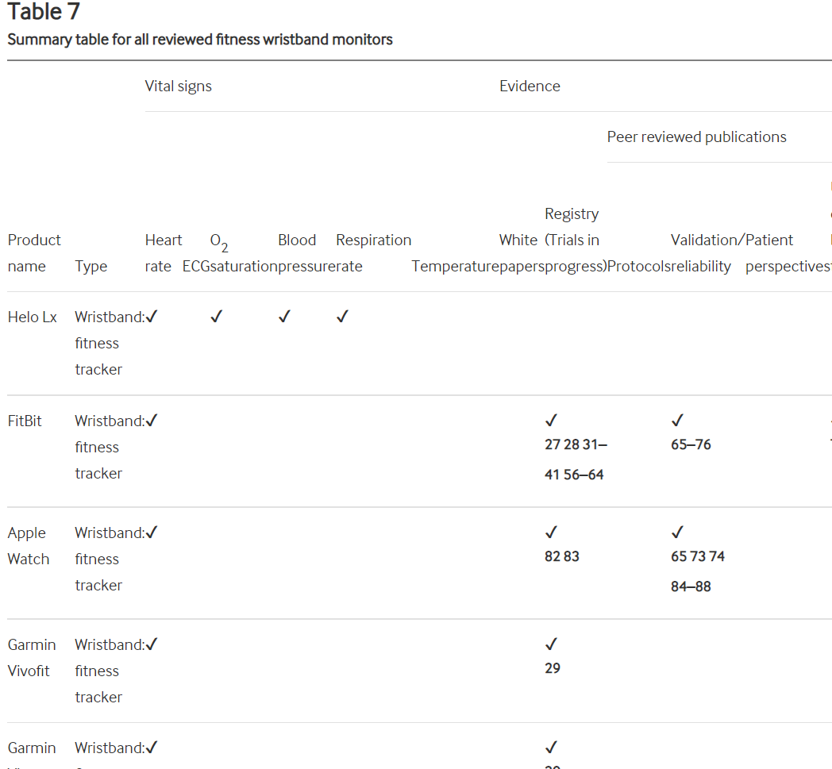
You can check a complete list of all the devices & sensors here:
https://innovations.bmj.com/content/6/2/55

Motivation of the Project
“If you have life, you have the world”. So, under the light of this great saying, the most valuable and primary thing in this world is life. Medical and health services have always been a top priority of science and technology. The advent of technology has leveraged the medical sector. A few centuries ago, obsolete criteria of diagnosing were in practice and herbal plants were prescribed as medicinal doses. In the past few decades, the advancements and digitisation in health care services have brought a drastic change in the lives of patients and medical experts. The evolution of mobile technologies and smart devices in the arena of health care has greatly impacted the obsolete ways of diagnosis and treatment. Health experts are taking advantage of the wonders of these cutting edge technologies, thus flourishing digitisation in clinical, hospital and pharmaceutical industries. Likewise, millions of people use M-Health (Mobile Health) applications and E-Health (health care supported by ICT) daily for routine medical check-ups and to keep a track of their health. Internet of Things (IoT) has enabled almost every digital device to be able to get connected to the internet, which in terms of health care is being used to send real-time data across the internet, hence making it easier for the medical advisors to diagnose and prescribe on a real-time basis. Chronic diseases such as diabetes, cardiac diseases and blood pressure among others, are considered as an economic and social threat to the world. Tele-monitoring uses information technology (IT) principles which have been deployed to remotely monitor the health of patients that are located in remote areas or homes in very crucial circumstances so that due to several reasons they are not able to have an appointment at the hospital or medical centres. For that, wearable medical sensors, such as pulse sensor, temperature sensor etc. have been employed to acquire real-time information from remotely located patients via the Internet.
Employing of pervasive medical devices and their connectivity with the advanced networks or the Internet created the new horizons for medical treatment. One such example is the use of wireless body area networks (WBANs), in which the dedicated sensors retrieve information such as temperature, heart/pulse rates, and other medical signals, via the connectivity of wireless media including cellular networks. The use of automated health analytics tools like ECG (electrocardiogram) analysers have enhanced the analysis and track record of the disease.
Emerging technologies like Cloud computing have taken tele-monitoring and health care systems to the next level. Cloud computing has been playing tremendous roles in the medical field in terms of real-time information monitoring, processing, analysis and storage. Cloud computing is an efficient and scalable solution. Deployment of public cloud services at a hospital or medical centre can enhance the productivity in terms of better diagnosis, treatment, medical records history, analysis and can lead to an improved administration and technology-enabled organisation. Using Cloud services information such as health care records etc. can be retrieved from any place 24/7. Peripheral devices like wearable sensor devices, sensor networks, Bluetooth devices, and Wi-Fi module based sensor devices have enabled the treatment of remotely home-resident critical patients. Usually, these dedicated sensors are embedded or attached to specific parts (like chest, finger etc.) of the human body and transmit the data through wired or wireless connections. Telemedicine is an amazing tool which is best suited for remote health care delivery and home care. In the last decades, several kinds of research have been conducted for the development of advanced context-aware medical applications, by a combination of computer networks, cellular networks (e.g., 2G, GRPS, and 3G), and wearable sensor networks. Indeed technology has revolutionized medical science with accuracy, efficiency and pace.

Objectives:
a) Eradicate the obsolete ways of diagnosis & monitoring
b) Portable & Feasible solution to healthcare industry
c) Disruption by being the economical and minimal viable product

Applications/Features:
- Monitoring of Vital human organs
- Activity Status
- Diagnosing
- Predictions
- Value Added features like Health Bot
- Tele-Health
- Diet Recommendations
Gantt Chart:

Work/Schedule Plan | Nov-Dec 2021 | Dec-Jan 2022 | Feb-Mar 2022 | Mar-April 2022 | April-May 2022 | June-July 2022
Literature Review
Survey of Wearable Devices
Cloud Deployment
Data Preprocessing & Model Development
Mobile & Web Apps Development
Thesis writing

References:
1.Wearable Health Devices—Vital Sign Monitoring, Systems and Technologies Duarte Dias 1,* ID and João Paulo Silva Cunha 1,2 (https://www.ncbi.nlm.nih.gov/pmc/articles/PMC6111409/)
2. Lymberis A.G.L. Wearable health systems: From smart technologies to real applications; Proceedings of the Annual International Conference of the IEEE Engineering in Medicine and Biology Society; New York, NY, USA. 30 August–3 September 2006; pp. 6789–6792. [PubMed] [Google Scholar]
3. Rita Paradiso G.L., Taccini N. A Wearable Health Care System Based on Knitted Integrated Sensors. IEEE Trans. Inf. Technol. Biomed. 2005;9:337–344. doi: 10.1109/TITB.2005.854512. [PubMed] [CrossRef] [Google Scholar]
4. Seoane F., Mohino-Herranz I., Ferreira J., Alvarez L., Buendia R., Ayllon D., Llerena C., Gil-Pita R. Wearable biomedical measurement systems for assessment of mental stress of combatants in real time. Sensors. 2014;14:7120–7141. doi: 10.3390/s140407120. [PMC free article] [PubMed] [CrossRef] [Google Scholar]
5. Yilmaz T., Foster R., Hao Y. Detecting vital signs with wearable wireless sensors. Sensors. 2010;10:10837–10862. doi: 10.3390/s101210837. [PMC free article] [PubMed] [CrossRef] [Google Scholar]
6. Statista B.I. Wearable Device Sales Revenue Worldwide from 2016 to 2022 (in Billion U.S.Dollars) Statista Inc.; New York, NY, USA: 2017. [Google Scholar]
7. Yussuff V., Sanderson R. The World Market for Wireless Charging in Wearable Technology. IHS; Englewood, CO, USA: 2014. [Google Scholar]
8. Khan Y., Ostfeld A.E., Lochner C.M., Pierre A., Arias A.C. Monitoring of vital signs with flexible and wearable medical devices. Adv. Mater. 2016;28:4373–4395. doi: 10.1002/adma.201504366. [PubMed] [CrossRef] [Google Scholar]
9. Majumder S., Mondal T., Deen M.J. Wearable sensors for remote health monitoring. Sensors. 2017;17:130. doi: 10.3390/s17010130. [PMC free article] [PubMed] [CrossRef] [Google Scholar]
10. Pantelopoulos A., Bourbakis N.G. A Survey on Wearable Sensor-Based Systems for Health Monitoring and Prognosis. IEEE Trans. Syst. Man Cybern. Part C Appl. Rev. 2010;40:1–12. doi: 10.1109/TSMCC.2009.2032660. [CrossRef] [Google Scholar]
11. Banaee H., Ahmed M.U., Loutfi A. Data mining for wearable sensors in health monitoring systems: A review of recent trends and challenges. Sensors. 2013;13:17472–17500. doi: 10.3390/s131217472. [PMC free article] [PubMed] [CrossRef] [Google Scholar]
12. Ahrens T. The most important vital signs are not being measured. Aust. Crit Care. 2008;21:3–5. doi: 10.1016/j.aucc.2007.12.061. [PubMed] [CrossRef] [Google Scholar]
13. Elliott M.C.A. Critical care: The eight vital signs of patient monitoring. Br. J. Nurs. 2012;21:621–625. doi: 10.12968/bjon.2012.21.10.621. [PubMed] [CrossRef] [Google Scholar]
14. Xu P.J., Zhang H., Tao X.M. Textile-structured electrodes for electrocardiogram. Text. Prog. 2008;40:183–213. doi: 10.1080/00405160802597479. [CrossRef] [Google Scholar]
15. Chan M., Esteve D., Fourniols J.Y., Escriba C., Campo E. Smart wearable systems: Current status and future challenges. Artif. Intell. Med. 2012;56:137–156. doi: 10.1016/j.artmed.2012.09.003. [PubMed] [CrossRef] [Google Scholar]
16. Appelboom G., Camacho E., Abraham M.E., Bruce S.S., Dumont E.L., Zacharia B.E., D’Amico R., Slomian J., Reginster J.Y., Bruyere O., et al. Smart wearable body sensors for patient self-assessment and monitoring. Arch. Public Health. 2014;72:28. doi: 10.1186/2049-3258-72-28. [PMC free article] [PubMed] [CrossRef] [Google Scholar]
17. Saritha C., Sukanya V., Murthy Y.N. ECG Signal Analysis Using Wavelet Transforms. Bulg. J. Phys. 2008;35:68–77. [Google Scholar]
18. Luo N., Ding J., Zhao N., Leung B.H.K., Poon C.C.Y. Mobile Health: Design of Flexible and Stretchable Electrophysiological Sensors for Wearable Healthcare Systems; Proceedings of the 2014 11th International Conference on Wearable and Implantable Body Sensor Networks; Zurich, Switzerland. 16–19 June 2014; pp. 87–91. [CrossRef] [Google Scholar]
19. Giovangrandi L., Inan O.T., Banerjee D., Kovacs G.T. Preliminary results from BCG and ECG measurements in the heart failure clinic; Proceedings of the 2012 Annual International Conference of the IEEE Engineering in Medicine and Biology Society; San Diego, CA, USA. 28 August–1 September 2012; pp. 3780–3783. [PubMed] [Google Scholar]
20. Syduzzaman M., Patwary S.U., Farhana K., Ahmed S. Smart textiles and nano-technology: A general overview. J. Text. Sci. Eng. 2015;5:1000181. [Google Scholar]
21. Aleksandrowicz A., Leonhardt S. Wireless and non-contact ECG measurement system—The “Aachen SmartChair” Acta Polytech. 2007;47:4–5. [Google Scholar]
22. Aarts V., Dellimore K.H., Wijshoff R., Derkx R., Laar J.V.D., Muehlsteff J. Performance of an accelerometer-based pulse presence detection approach compared to a reference sensor; Proceedings of the 14th Annual Body Sensor Networks Conference; Eindhoven, The Netherlands. 9–12 May 2017; pp. 165–168. [Google Scholar]
23. Xiao-Fei T., Yuan-Ting Z., Poon C.C.Y., Bonato P. Wearable Medical Systems for p-Health. IEEE Rev. Biomed. Eng. 2008;1:62–74. doi: 10.1109/RBME.2008.2008248. [PubMed] [CrossRef] [Google Scholar]
24. Turner J.R., Viera A.J., Shimbo D. Ambulatory blood pressure monitoring in clinical practice: A review. Am. J. Med. 2015;128:14–20. doi: 10.1016/j.amjmed.2014.07.021. [PMC free article] [PubMed] [CrossRef] [Google Scholar]
25. Puke S., Suzuki T., Nakayama K., Tanaka H., Minami S. Blood pressure estimation from pulse wave velocity measured on the chest; Proceedings of the 2013 35th Annual International Conference of the IEEE Engineering in Medicine and Biology Society (EMBC); Osaka, Japan. 3–7 July 2013; pp. 6107–6110. [PubMed] [Google Scholar]
26. Yu-Pin H., Young D.J. Skin-Coupled Personal Wearable Ambulatory Pulse Wave Velocity Monitoring System Using Microelectromechanical Sensors. IEEE Sens. J. 2014;14:3490–3497. [Google Scholar]
27. Woo S.H., Choi Y.Y., Kim D.J., Bien F., Kim J.J. Tissue-informative mechanism for wearable non-invasive continuous blood pressure monitoring. Sci. Rep. 2014;4:6618. doi: 10.1038/srep06618. [PMC free article] [PubMed] [CrossRef] [Google Scholar]
28. Guo L., Berglin L., Wiklund U., Mattila H. Design of a garment-based sensing system for breathing monitoring. Text. Res. J. 2012;83:499–509. doi: 10.1177/0040517512444336. [CrossRef] [Google Scholar]
29. Gandis G., Mazeika M., Rick Swanson R. CRTT. Respiratory Inductance Plethysmography an Introduction. [(accessed on 5 June 2017)]; Available online: http://www.pro-tech.com/
30. Anmin J., Bin Y., Morren G., Duric H., Aarts R.M. Performance evaluation of a tri-axial accelerometry-based respiration monitoring for ambient assisted living; Proceedings of the Engineering in Medicine and Biology Society; Minneapolis, MN, USA. 3–6 September 2009; pp. 5677–5680. [PubMed] [Google Scholar]

